Day 3

10/8/2023

Day 3

1410/2023

CI and CD

Continuous Integration and Continuous deployment and Delivery

After push the code by dev1 or dev2 or dev3 we need to merge it. After merge

We need to built it once again. It may be build successfully or failure

Dev1 Shared Remote Repository

Clone Git Hub

Create user defined branch and do the task

Then compile, run, test ie build the code.

Then will push code.

Dev2 Git Lab

Clone Bit bucket

Create user defined branch and do the task

Then compile, run, test ie build the code.

Then will push code.

Dev3 Any private cloud

Clone

Create user defined branch and do the task

Then compile, run, test ie build the code.

Then will push code.

Manager

After pull the code from shared repository manager need to pull the code

In their machine and merge it and re – built it.

Dev1 login page using html with css

Dev2 write business logic to check user name and password from database. Using java or python

Dev3 to create table in database like mysql or oracle.

Jenkins : Jenkin is an open source CI and CD tool. It is also known as automation Server.

Jenkin internal logic written using Java technologies. Jenkin is plugin based and GUI base CI and CD tools.

Graphical user interface.

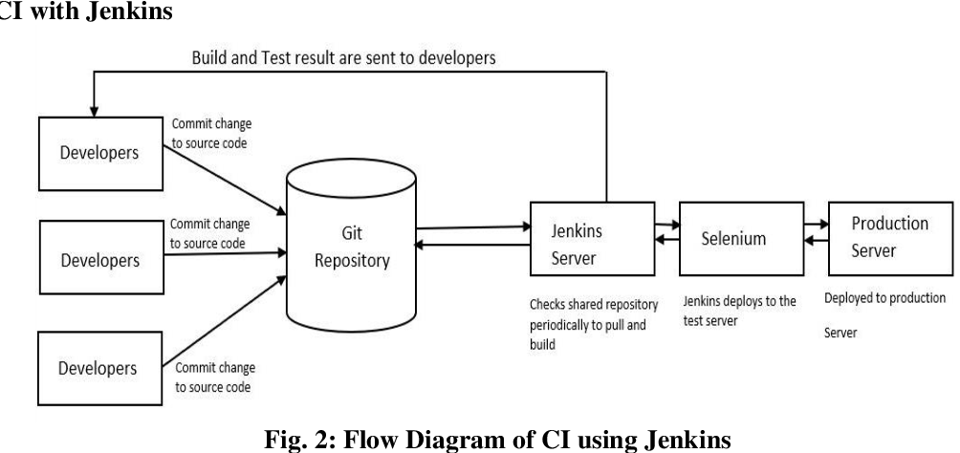

By default Jenkin server run on default port number 8080.

Please logic in VM

In VM :open the browser and write the URL as

In VM first time it will ask pop up message with login id and password : no 2 times

<http://localhost:8080>

username : admin

password : admin

<http://187.65.87.45:8080>

or

<http://jenkinsserver.com>

Ant, Maven and Gradel are java build tool. Build tool is responsible to compile, run, execute running application and documentation.

FirstJob : it display simple echo message.

SecondJob : it is responsible to execute set of command or one command

Again and again base upon trigger.

sudo service Jenkins status

it will display the status of Jenkin

cntr + c or cntr + d to exit

sudo service jenkin stop

sudo service jenkin start

open the terminal

java --version

third Jenkin job

this job must be pull the project from remote repository which contains java program.

Pull it in Jenkin environment and build the project.

1st without trigger . then we need to re-build the project.

2nd with trigger : cron time 1 min

3rd

Trigger periodically Vs Poll SC

It will build the project base upon time interval again and again.

It will only build if any changes happen in remote repository in particular branch.

Node : Node is a run time environment for JavaScript programs.

Frontend side technologies :

Html, css, JavaScript, typescript, jQuery, Angular, react, Vue JS

It is use to create the Web Application like a website.

Google, Facebook, Gmail etc.

Backend side technologies

Java or Spring boot etc

Asp.net

Php

Python

Node Js : Using JavaScript we can create server side or backend side technologies.

Database : store the data.

MySQL, Oracle, Db2, Sql Server : RDBMS Relational Database Management System

They store the data in table format.

Data : can be in any format like structure or semi structure format (json or xml) or non structure format.

NoSQL Database

Mongo db , Neo4J, Cassandra, HBase etc.

How to install required plugin to run the job base upon any technologies.

We will run Jenkin using war file

First stop running jenkin in VM using command as

sudo service Jenkins stop

download Jenkin war file using below URL

<https://www.jenkins.io/download/>

it will download in default path ie Downloads

open the terminal in Downloads folder

and run the command as

java -jar Jenkins.war

after few command executed you can see random alpha number password.

Then open the browser

<http://localhost:8080>

it will ask the password

please paste the password which present in console screen.

install suggested plugins

then create you account with you username and password

username : admin

password : admin